IT24104011

Kodithuwakku D.P.A

Probability And Statistics Labsheet 08

Exercises

#Q1

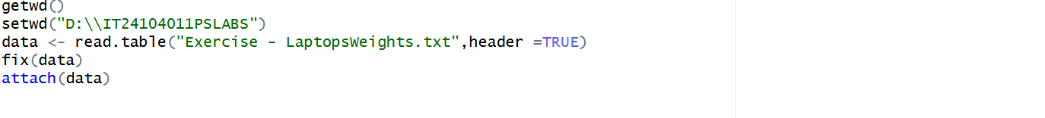

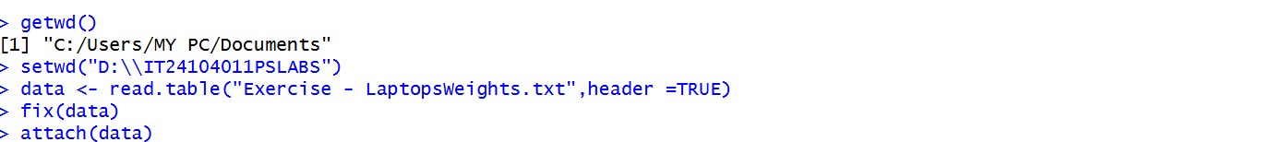

#Q1

#Q2

#Q3

